**Matt Knutson**

**CS-360: Mobile Architecture & Programming**

**SNHU - Instructor Walker**

**August 4th, 2024**

**Week 5 - Project 2**

**EventzGeo**

**The App Folder**

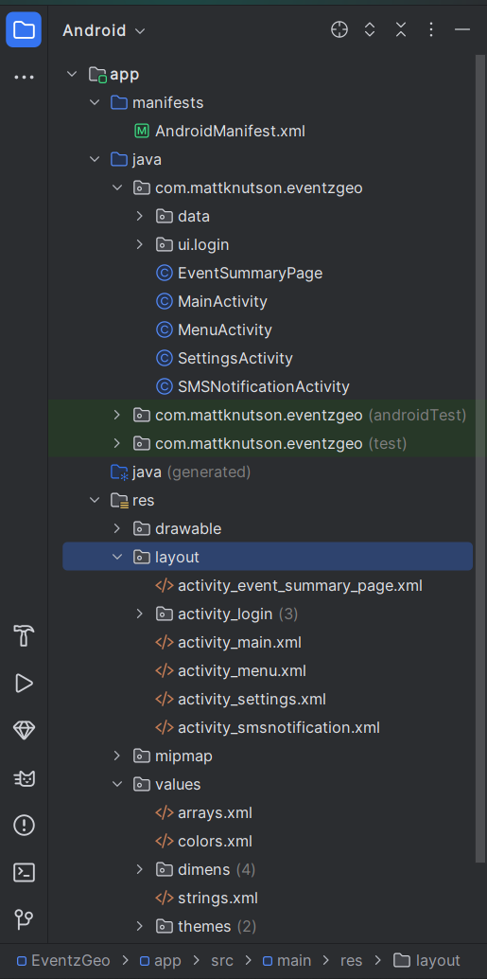

**Login Page**

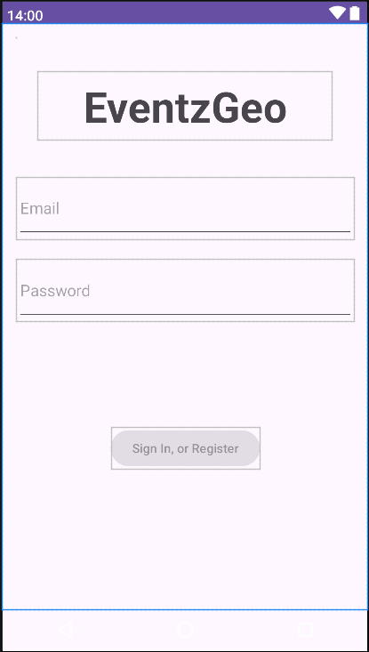

**User Must Confirm Phone Number**

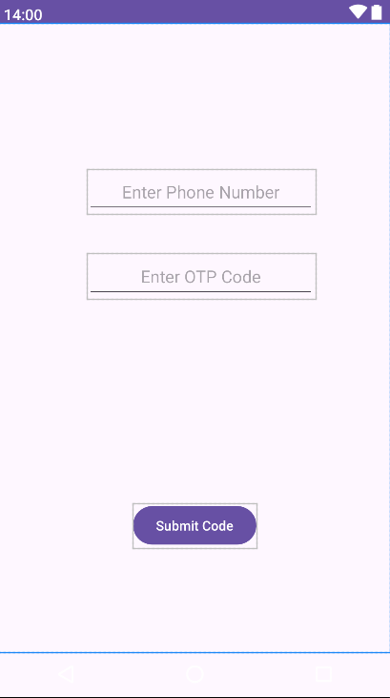

**The Main Page**

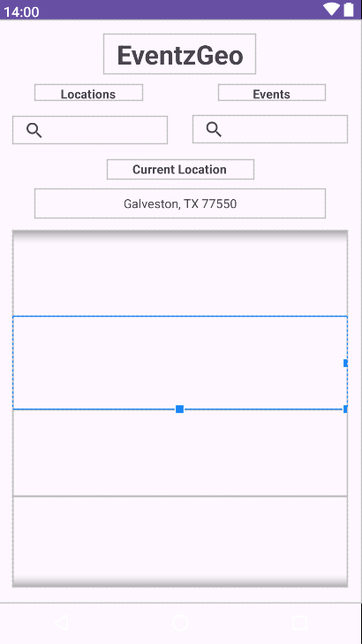

**An Event Summary Page**

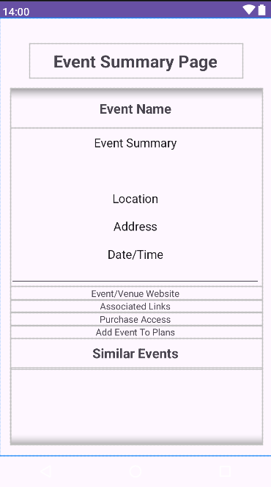

**The Menu**

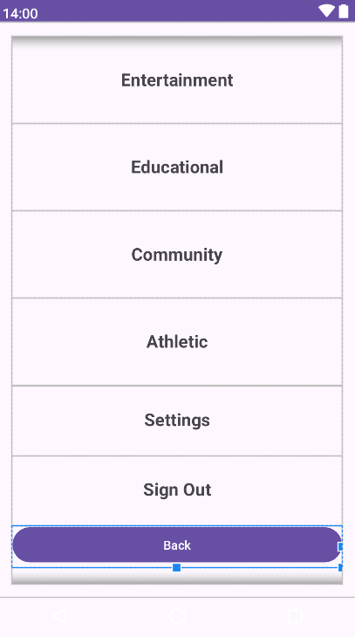

**Settings**

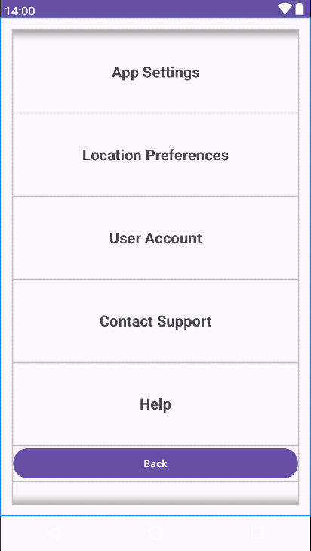

**.telephony feature & SEND_SMS permission.**

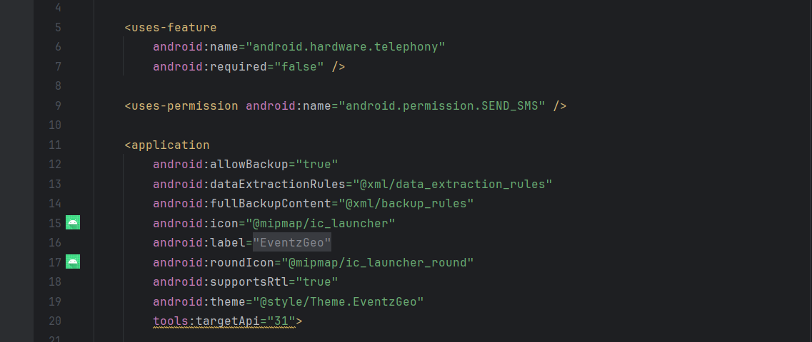

**The app will start on the login page.**

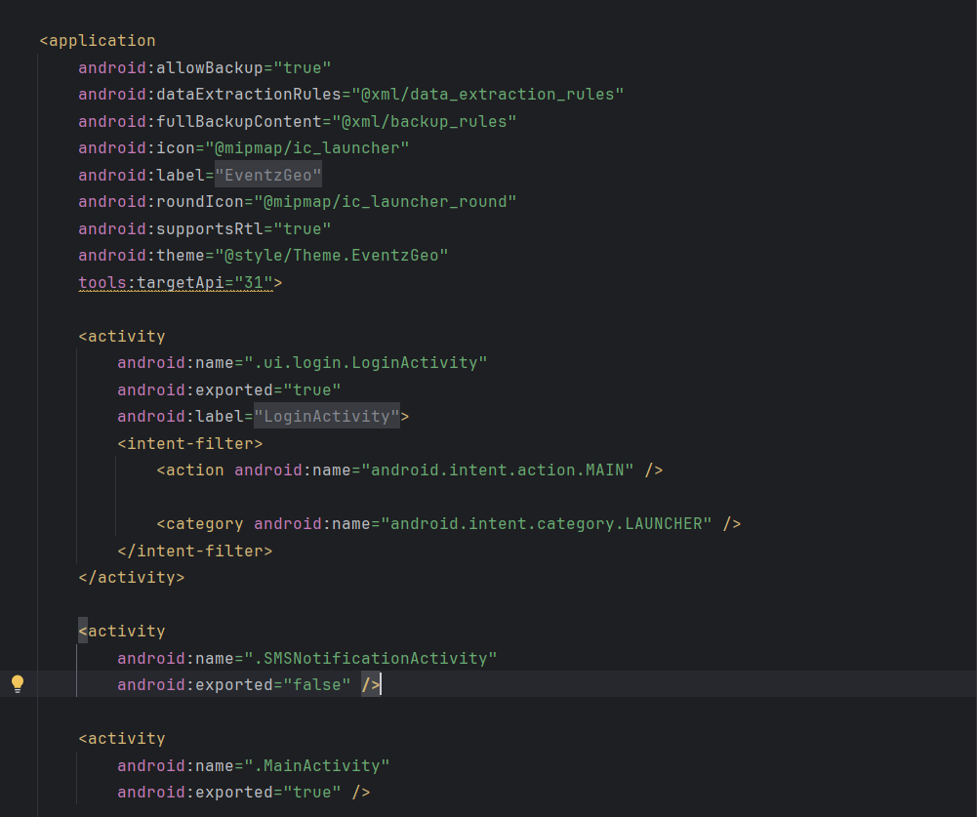

**All Strings are handled appropriately.**

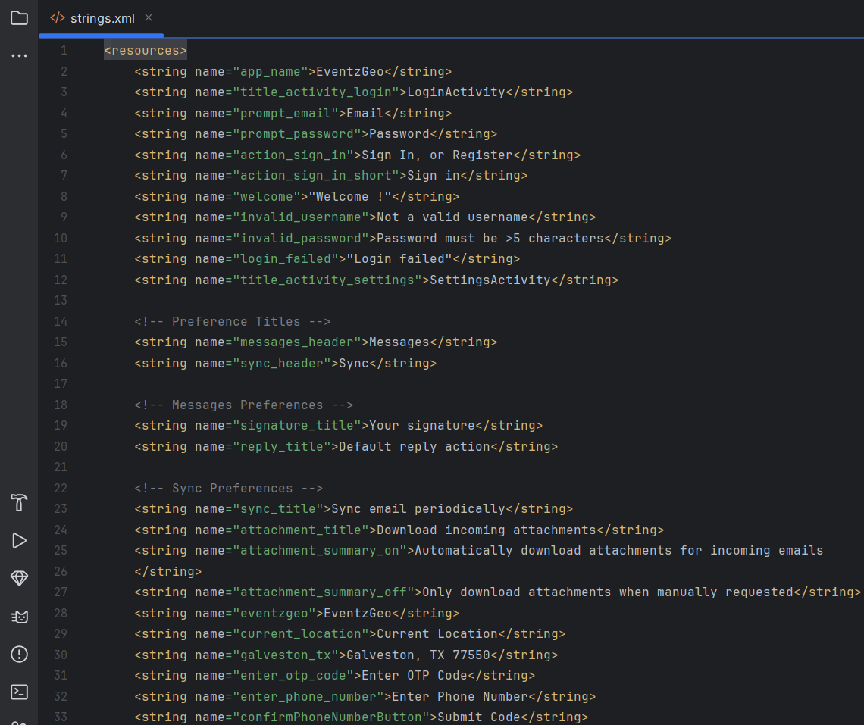

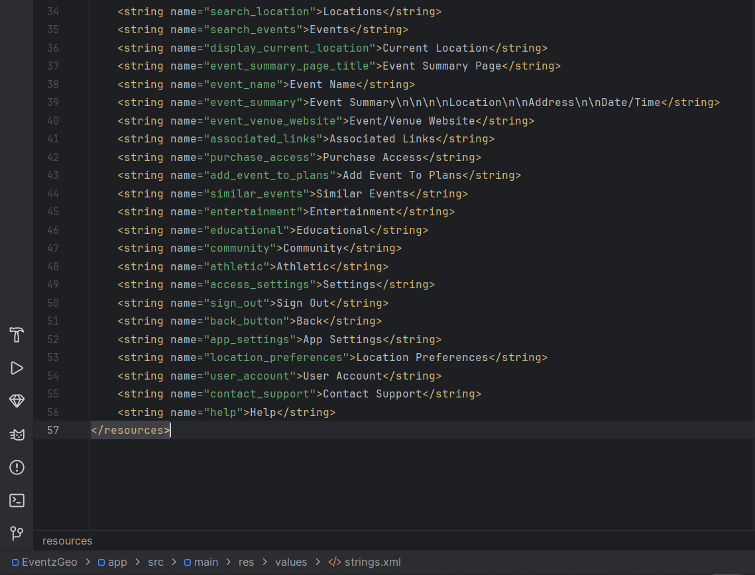

**The app starts and opens to the correct page.**

